Global Health Film Festival
Website & Logo
Website Specks:
- If you can design the site so I can upload images into the template and modify text that would be ideal.
- The plugins for Twitter/Instagram/FB ect should be automatic feed into the website and I am open to creative ideas of how to incorporate this.
- Also we would want the videos chosen to be embedded into the website after the festival, maybe having teaser clips on the website prior to the festival.
- Here is a link to a teaser of one of the videos that will be showcased so you can get a feel for the vibe & quality: https://www.youtube.com/watch?v=f6aBH97bi0w
Themes (examples):
- Dark background with white highlights, I like the below sites visually
- Don’t have a font type preference but needs to be clean (no cursive ect)
- I am open to a more creative layout but the PowerPoint has the Sitemap hierarchy I am looking for.
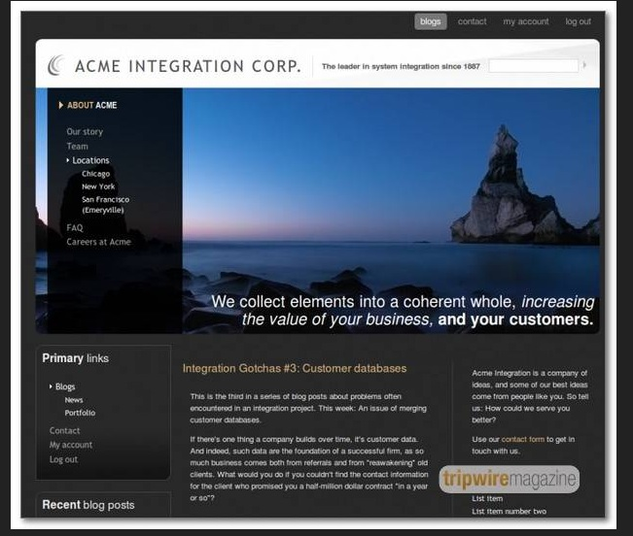
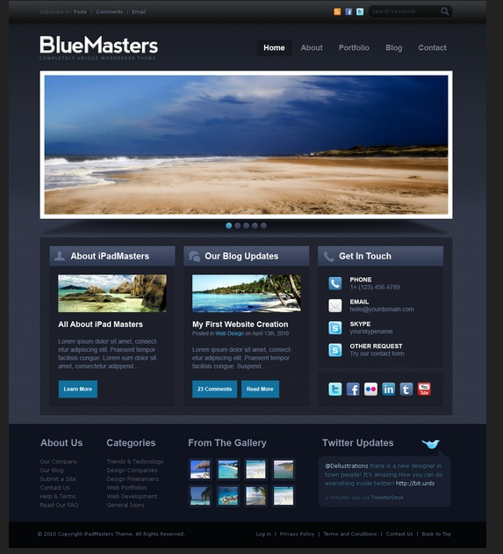
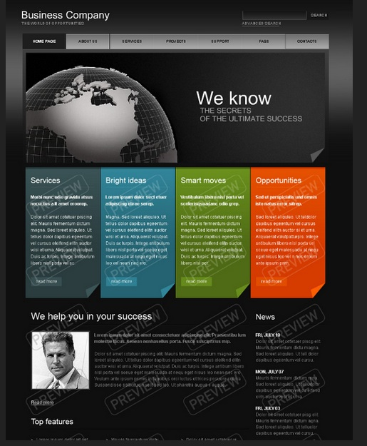

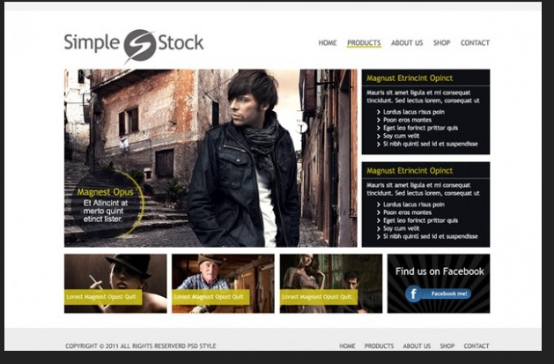

Logo Design:
Vintage Camera with globe outline in lens, similar to the Save The Waves 2010 Film Festival Logo


